Practical : 9

## Aim : Create Home page of your website using master page concept.

HeaderFooter.Master

<%@ Master Language="VB" AutoEventWireup="false" CodeBehind="HeaderFooter.master.vb" Inherits="Practical_09.HeaderFooter" %>

<!DOCTYPE html PUBLIC "-//W3C//DTD XHTML 1.0 Transitional//EN" "http://www.w3.org/TR/xhtml1/DTD/xhtml1-transitional.dtd">

<html xmlns="http://www.w3.org/1999/xhtml">

<head id="Head1" runat="server">

<title>Milk Prism</title>

<style type="text/css">

#header{

color: #247BA0;

text-align: center;

font-size: 20px;

}

#nav{

background-color:Blue;

padding: 5px;

}

li a {

color: #F1FAEE;

font-size: 30px;

column-width: 5%;

}

li

{

display: inline;

padding-left: 2px;

column-width: 20px;

}

a{

text-decoration: none;

margin-left:20px

}

li a:hover{

background-color: #F3FFBD;

color: #FF1654;

padding:1%;

}

#footer{

background-color: #C7EFCF;

text-align:center;

padding-bottom: 5%;

font-size: 20px;

}

#con{

border:double;

border-color:Fuchsia;

}

</style>

<asp:ContentPlaceHolder ID="head" runat="server">

</asp:ContentPlaceHolder>

</head>

<!DOCTYPE html>

<body>

<header id="header">

<h1>MilkPrism</h1>

</header>

<nav id="nav">

<ul>

<li><a href="home.aspx">Find Us</a></li>

<li><a href="#">Contact Us</a></li>

<li><a href="#">Login</a></li>

<li><a href="#">Sign Up</a></li>

</ul>

</nav>

<div id="con">

<asp:ContentPlaceHolder ID="ContentPlaceHolder1" runat="server">

</asp:ContentPlaceHolder>

</div>

<footer id="footer">

insta : milkprism

fb : milkprism

</footer>

</body>

</html>

Home.aspx

<%@ Page Title="" Language="vb" AutoEventWireup="false" MasterPageFile="~/HeaderFooter.Master" CodeBehind="Home.aspx.vb" Inherits="Practical_09.Home" %>

<asp:Content ID="Content1" ContentPlaceHolderID="head" runat="server">

</asp:Content>

<asp:Content ID="Content2" ContentPlaceHolderID="ContentPlaceHolder1" runat="server">

<h1>Home Page</h1>

</asp:Content>

Output :

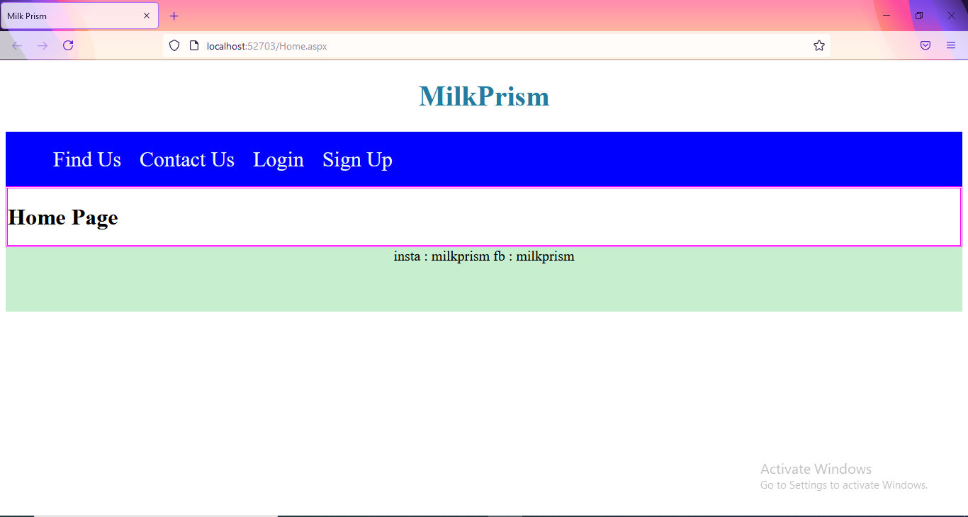

|  |  |  |  |
| --- | --- | --- | --- |
| Start Date | End/Sign Date | Faculty Sign | Remarks/Grade |
|  |  |  |  |

Practical : 10

## Aim : Create a simple web application to illustrate the concept of nesting master page in ASP.NET.

Master.Master

<%@ Master Language="VB" AutoEventWireup="false" CodeBehind="Master.master.vb" Inherits="Practical_10.Master" %>

<!DOCTYPE html PUBLIC "-//W3C//DTD XHTML 1.0 Transitional//EN" "http://www.w3.org/TR/xhtml1/DTD/xhtml1-transitional.dtd">

<html xmlns="http://www.w3.org/1999/xhtml">

<head runat="server">

<title></title>

<asp:ContentPlaceHolder ID="head" runat="server">

</asp:ContentPlaceHolder>

</head>

<body>

<form id="form1" runat="server">

<div>

<table cellpadding="50px" style="border:3px Solid Red;">

<tr>

<td colspan="2" align="center">

Header Part

</td>

</tr>

<tr>

<td width="20%" colspan="2">

&nbsp<asp:ContentPlaceHolder ID="ContentPlaceHolder1" runat="server">

</asp:ContentPlaceHolder>

</td>

</tr>

<tr>

<td colspan="2" align="center">

Footer Part

</td>

</tr>

</table>

</div>

</form>

</body>

</html>

SideBar.master

<%@ Master Language="VB" MasterPageFile="~/Master.Master" AutoEventWireup="false" CodeBehind="SideBar.master.vb" Inherits="Practical_10.SideBar" %>

<asp:Content ID="Content1" ContentPlaceHolderID="head" runat="server">

</asp:Content>

<asp:Content ID="Content2" ContentPlaceHolderID="ContentPlaceHolder1" runat="server">

<table width="60%" style="border:2px dotted blue;">

<tr>

<td width="40%">Sidebar</td>

<td><asp:ContentPlaceHolder ID="cph" runat="server"></asp:ContentPlaceHolder></td>

</tr>

</table>

</asp:Content>

Shops.aspx

<%@ Page Title="" Language="vb" AutoEventWireup="false" MasterPageFile="~/SideBar.master" CodeBehind="Shops.aspx.vb" Inherits="Practical_10.Shops" %>

<asp:Content ID="Content1" ContentPlaceHolderID="cph" runat="server">

Krishna Dairy

<br />

Kandhenu Dairy

<br />

Amul

<br />

Sumul

<br />

Havemor Eatery

</asp:Content>

Output :

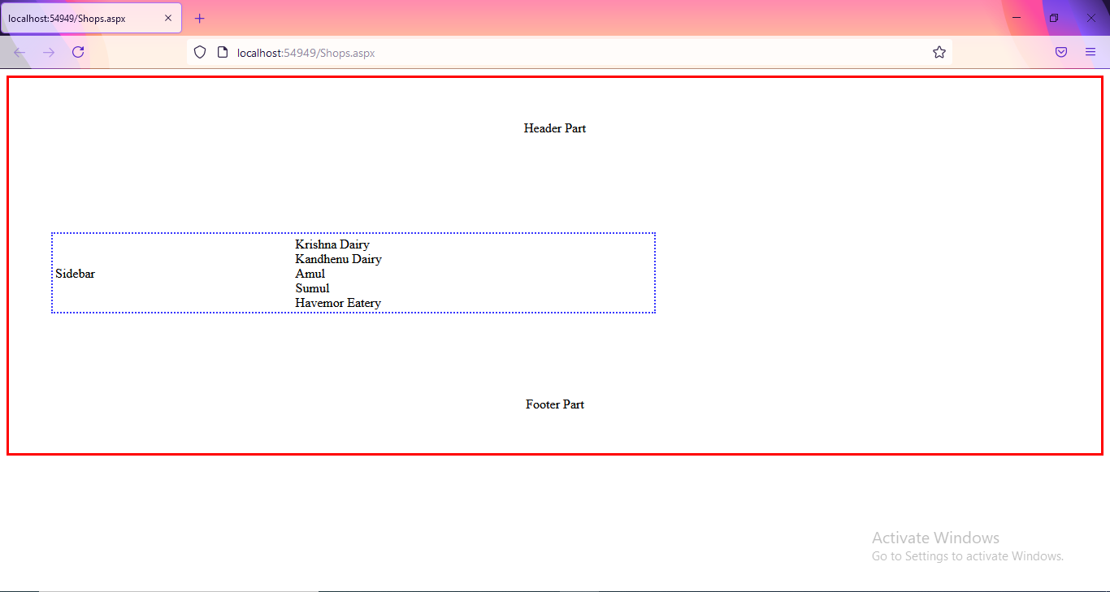

|  |  |  |  |
| --- | --- | --- | --- |
| Start Date | End/Sign Date | Faculty Sign | Remarks/Grade |
|  |  |  |  |